ỦY BAN NHÂN DÂN THÀNH PHỐ HỒ CHÍ MINH
TRƯỜNG CAO ĐẲNG LÝ TỰ TRỌNG THÀNH PHỐ HỒ CHÍ MINH

BÀI GIẢNG CHI TIẾT

Môn học: VIẾT
Lớp : 18T4-NNA1,2,3 Khoá : 2018
Họ và tên giảng viên : TRẦN THANH TRÚC.
Năm học: 2019 - 2020

Quyển số:.......
UNIT 1 THE SENTENCE AND THE PARAGRAPH

PART 1: STIMULATING IDEAS
- Reorder the sentences above to make a complete and meaningful paragraph
______ One evening while my parents were eating dinner. I was playing barefoot in the yard with my toys. Even now I still remember the perfume of the flowers and the moisture of the grass.
______I had a scary experience when I was a young boy.
______While I was sitting on the grass and playing with a truck. I looked up at the sky, and my attention was distracted by the beauty of the stars.
______I felt terrible and afraid, so my heart beat very fast. After the snake moved away. I screamed to my parents for help, and they captured the snake and took it away.
______The experience frightened me, and I never went outside barefoot again.
______Then I felt something cold and smooth slide over my feet. I stayed perfectly still, but I looked down at my feet. Then I saw a snake slowly slithering over my toes.
- Analyze the paragraph
Discussion questions:
What is the first sentence about?
How did the writer support the first sentence?
Which sentences show the writer’s feelings about the experience?
What is the last sentence about?
Does the last sentence repeat the information in the topic sentence in a new way?
- Lesson: PARAGRAPH
Summary:
+ The Paragraph
A paragraph is a group of sentence about the topic
+ Formatting a Paragraph
Margins
A paragraph must have a margin on the right and a margin on the left. This means that the paragraph begins 1 inch or 1 1/4 inches from the edge of the paper.
Spacing
A paragraph should be double-spaced.
Indenting
The first sentence of a paragraph must be indented. This means that it begins five spaces in from the left margin. Indenting shows the reader that a new paragraph is beginning. On a computer, you can indent with the Tab key.
Connected Sentences
The sentences in a paragraph should follow each other. It is not a paragraph if every sentence begins on a new line. A well-supported paragraph has at least 5 sentences and often more.
Title
A paragraph by itself usually has a title. This is one word or a group of words that tells what the topic is.
- Practice
Exercise 2/ P.4
Answer key: 1 d – 2 c – 3 a – 4b

PART 2: DEVELOPING A PARAGRAPH
2.1. Paragraph organization
a. Lesson
- Topic sentence: topic + controlling idea
- Supporting ideas: support the topic sentence
- Concluding sentence: repeat the topic sentence in a different way
b. Practice
Exercise 2/ p.6
Answer keys:
1. I had a scary experience when I was a young boy.
2. There are eight supporting sentences.
3. Yes.
4. The experience frightened me, and I never went outside barefoot again.
5. Yes.

2.2. The Topic Sentence
a. Lesson
- 1 first sentence
- Introduces 1 new idea
- Presents the topic
- Includes controlling ideas (explains what the writer will say about the topic)
b. Practice
Exercise 3, 4, 5/ p.7
Answer keys:
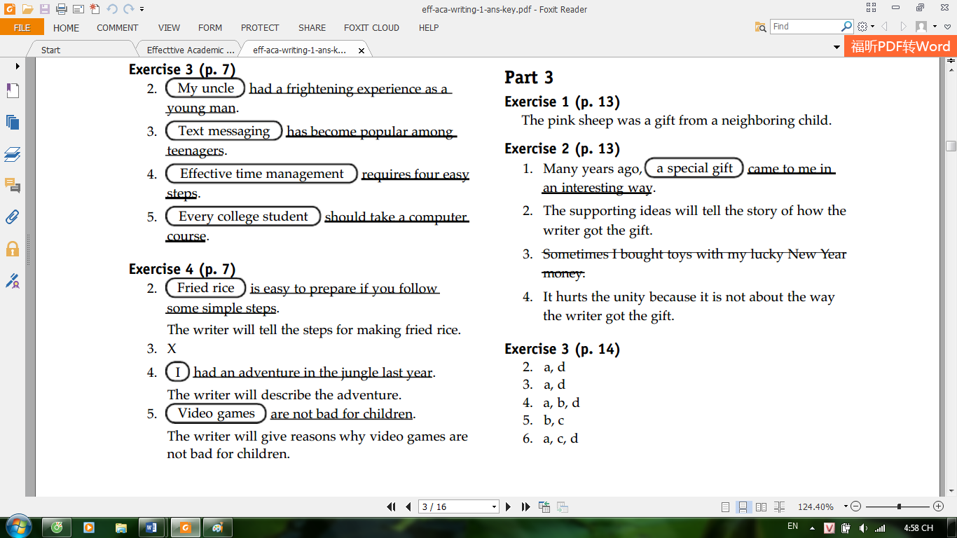
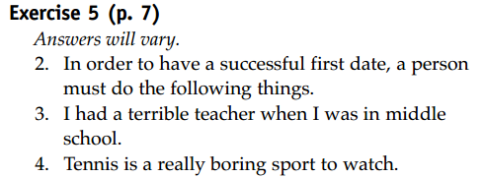

2.3. Supporting Sentences
a. Lesson
- Support the controlling ideas
- Include definition, examples, explanations...
b. Practice
Exercise 6/ p.8
Answer keys
2. a. TS | b. SS | c. SS | d. SS
3. a. SS | b. SS | c. SS | d. TS
4. a. SS | b. TS | c. SS | d. SS

2.3. Concluding Sentence
a. Lesson
- Restates the main idea
- Adds some information: warn the reader, give prediction, give an opinion about the topic
b. Practice
Exercise 7/ p.10
Answer keys
2. a. CS | b. SS | c. SS | d. SS
3. a. SS | b. SS | c. CS | d. SS
4. a. SS | b. SS | c. SS | d. CS
Exercise 7/ p.10, 11
Answer keys
2 c – 3 b – 4 a – 5 b – 6 c

PART 3: UNITY AND COHERENCE
  - Unity within a Paragraph
a. Lesson
- All sentences support a single idea
b. Practice
Exercise 1, 2, 3, 4/ p.13, 14
Answer keys
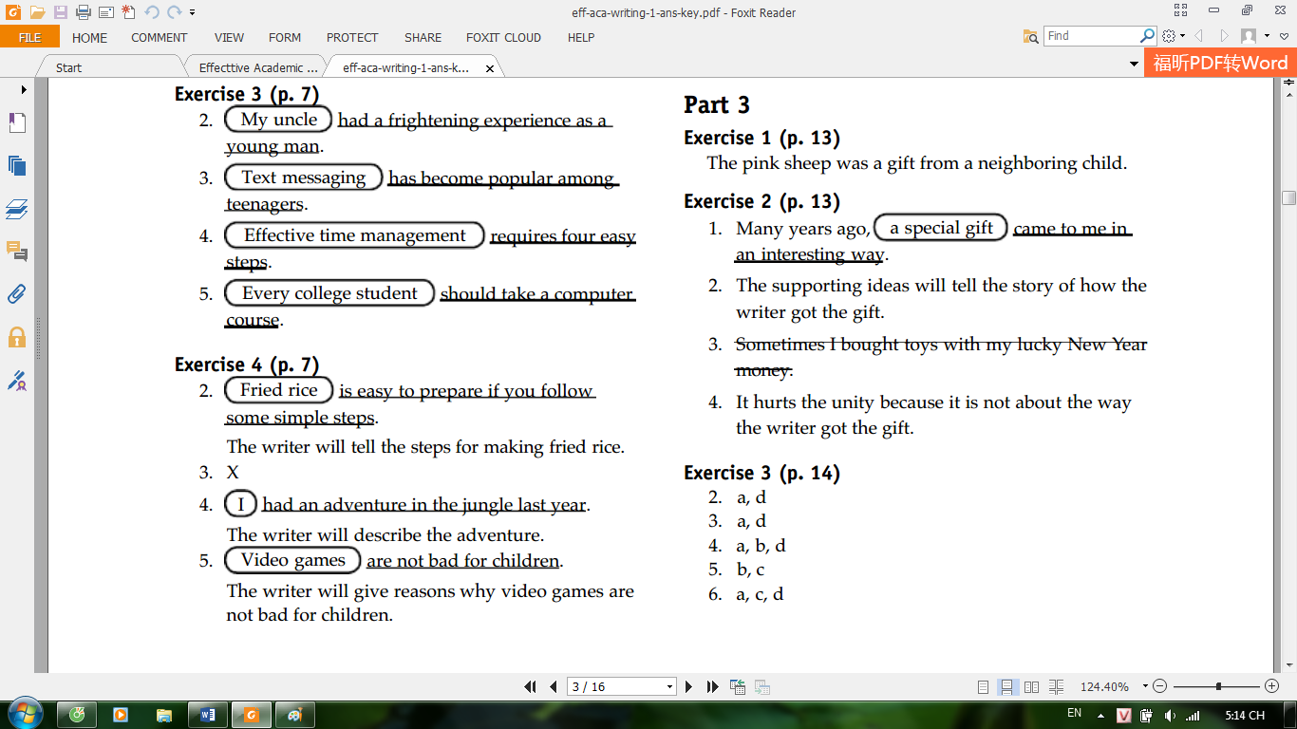
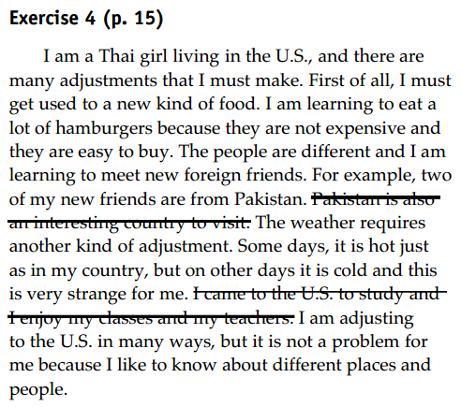

  - Coherence within a Paragraph
a. Lesson
- Supporting ideas are organized in a logical way.
- Order: time, space, importance …
b. Practice
Exercise 6/ p.17
Answer keys:
Para. 1: Order of importance
Para. 2: Order of time
Exercise 7/ p. 18
Paragraph 2 is better. It is organized in the order of importance

PART 4: EDITING YOUR WRITING
  - Simple Sentence Structure
a. Lesson
Subject: A person, animal, place, thing, or concept that does an action. Determine the subject in a sentence by asking the question “Who or what?”
Verb: Expresses what the person, animal, place, thing, or concept does. Determine the verb in a sentence by asking the question “What was the action or what happened?”
Object: A person, animal, place, thing, or concept that receives the action. Determine the object in a sentence by asking the question “The subject did what?” or “To whom?/For whom?”
Prepositional Phrase: A phrase that begins with a preposition (i.e., in, at for, behind, until, after, of, during) and modifies a word in the sentence. A prepositional phrase answers one of many questions. Here are a few examples: “Where? When? In what way?”
b. Practice
Exercise 1/ p.19
Answer keys:
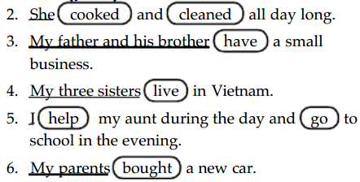
Exercise 2/ p. 20
Answer keys: Answers will vary

4.2. Punctuation and Capitalization
a. Lesson
A complete sentence that makes a statement ends with a period.
A question ends with a question mark.
The exclamation point is used at the end of a sentence to indicate great surprise. It is also used for emphasis when making a point. (strong feeling / excitement)
The first word in every sentence is capitalized, and so is the pronoun I.
b. Practice
Exercise 3/ p.21
Answer keys
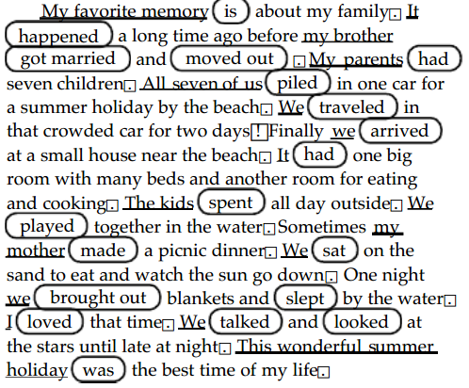

  - Fragments
a. Lesson
Sentence fragments are groups of words that look like sentences, but aren't. They are groups of words that are missing a subject or verb, or both.
Here's an example missing subject and verb:
From morning until night.
This fragment can be made a complete sentence by changing it to:
I worked from morning until night.
Adding 'I' as the subject and 'worked' as the verb corrects this fragment and makes it an independent clause and a complete thought.
Here's an example of a missing subject:
Start after the weekend.
This fragment can be made a complete sentence by changing it to:
Classes start after the weekend.
Adding the subject 'classes' corrects this fragment and makes it an independent clause and a complete thought.
Finally, here's an example of a missing verb:
Some girls in the class.
This fragment can be changed to:
Some girls in the class study together.
b. Practice
Answer keys: Answers will vary
Exercise 4/ p.22

4.4. Run-on Sentences
a. Lesson
A run-on sentence occurs when two or more independent clauses (also known as complete sentences) are connected improperly.
Example: I love to write papers I would write one every day if I had the time.
There are two complete sentences in the above example:
Sentence 1: I love to write papers.
Sentence 2: I would write one every day if I had the time.
b. Practice

* Practice:
Exercise 5/ p.23
Answer keys:
Answers will vary.
2. There are mice living underneath my house. They make a lot of noise at night.
3. I used to eat rice and vegetables for breakfast, but now I eat cereal and milk.
4. I do not drive, so I ride the bus.
5. I am saving money for a bicycle, and I also want to buy a camera.

Exercise 6/ p.23
Answer keys:
My mother’s cousin owned a hotel, and I worked there as a young man. I enjoyed this work very much. (1) I met many interesting people. One time a family came to stay in the hotel. They (2) had a daughter, (3) and she was my age. We met often and talked about our lives. I invited her to my house to meet my family. She told us about her life in the United States. We shared our customs with her. Later my mother told me something unforgettable. She said, “I know that you are going to
live in America.” My mother (4) is a very smart woman, (5) and she was right. I came to America to search for my friend. I am still looking.

PART 5: PUTTING IT ALL TOGETHER
a. Exercises 1-8/ p.24 - 28
Answer keys

Exercise 1 (p. 24)
1. d - 2. c - 3. a - 4. b

Exercise 2 (p. 24)
1. a. SS b. SS c. SS d. TS
2. a. SS. b. SS. c. TS d. SS
3. a. TS b. SS c. SS d. SS
4. a. SS b. TS c. SS d. SS

Exercise 3 (p. 25)
There They Are!
c. Now I am an adult, but I still feel joy when I go to the train station to meet someone I love.
A Wise Shopper
c. In conclusion, a wise shopper finds ways to save money on the price and to avoid buying what he
does not need.

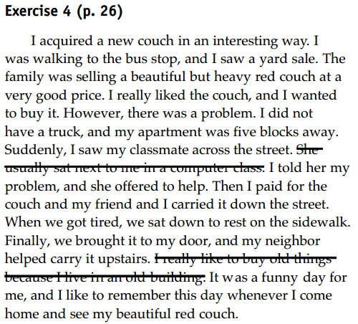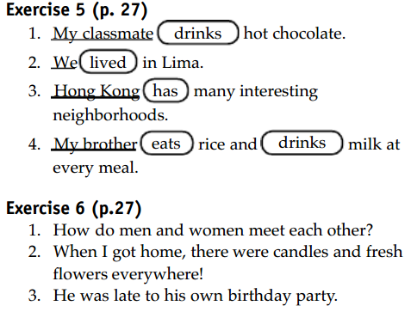

Exercise 7 (p. 27)
Answers will vary.
1. Suddenly, I fell down.
2. Thailand has a tropical climate.
3. I was walking beside the lake with my best friend.
4. Yesterday was an important day for me.

Exercise 8 (p. 28)
Answers will vary.
1. We watched a movie. It was about a dinosaur that lost its mother.
2. We have a harvest moon festival every year in our city. There are parades and kiosks with noodle
soup and other delicious food.
3. I had to stop going to school for a while because my father wanted me to help him with his
business.
4. Rice pudding is delicious and easy to make, and it is great for parties too.

b. Write a short paragraph (70-80 words) about a chosen topic.
c. Self-correction and Peer-correction

UNIT 2 DESCRIPTIVE PARAGRAPHS

PART 1: STIMULATING IDEAS
a. Analyze:
Reading Text: “The long life of my grandfather’s car”.
Exercise 4/ p.36
Answer key:
A. 1. C - 2. B - 3. A
B. 1. I own a car that has special meaning for me because it belonged to my grandfather.
2. beautiful, Cadillac convertible, white, blue, silver, powerful, black, brown leather, gray, clean, original, intact
3. special meaning, happy
4. I plan to take very good care of my grandfather’scar because someday I will use it to travel to all
the states and cities that my grandfather visited when he was a young man.
b. Lesson: DESCRIPTIVE PARAGRAPH
- Definition: A descriptive paragraph describes a person, thing, or place so that the reader can picture it in his or her mind.
- Descriptive organization:
- Topic sentence:
- The item
- General feelings/ opinions about the item
- Supporting sentences:
- Background information
- Descriptive details
- Writer’s feelings
- Concluding sentence:
- Restate the topic sentence

PART 2: BRAINSTORMING AND OUTLINING
2.1. Brainstorming skill
a. Lesson
Brainstorming techniques:
- Freewriting
When you freewrite, you let your thoughts flow as they will, putting pen to paper and writing down whatever comes into your mind. You don’t judge the quality of what you write and you don’t worry about style or any surface-level issues, like spelling, grammar, or punctuation.
- Break down the topic into levels
the general topic, like a specific subtopic or required question, like a single term or phrase that you sense you’re overusing in the paper.
- Cubing
Cubing enables you to consider your topic from six different directions: Describe it. Compare it. Associate it. Analyze it. Apply it. Argue for and against it. Similes
- Clustering/mapping/webbing:
Take your sheet(s) of paper and write your main topic in the center, using a word or two or three.
Moving out from the center and filling in the open space any way you are driven to fill it, start to write down, fast, as many related concepts or terms as you can associate with the central topic.
Once the storm has subsided and you are faced with a hail of terms and phrases, you can start to cluster. Circle terms that seem related and then draw a line connecting the circles.
- Journalistic questions
In this technique you would use the “big six” questions that journalists rely on to thoroughly research a story. The six are: Who?, What?, When?, Where?, Why?, and How
b. Practice
Exercise 1, 2/ p.33
Answer keys: The answer will vary

2.2 Outlining skill
a. Lesson
An outline allows a writer to categorize the main points, to organize the paragraphs into an order that makes sense, and to make sure that each paragraph/idea can be fully developed. Essentially, an outline helps prevent a writer from getting stuck when performing the actual writing of the essay.
b. Practice
Exercise 5/ p.36
Answer keys
Item the author describes: his car
The author’s general feeling about the item: It has special meaning for him.
Background information about the item: His father saved up to buy it and then drove around the country in it.
Descriptive information about the item: beautiful, Cadillac convertible, white and blue with silver trim, white circles on the tires, powerful horn, white seats, black dashboard, brown leather cover on the steering wheel, grandfather took very good care of the car, has original motor, body is intact
Details about the author’s feelings: He is happy the car has its original motor and the body is intact. He will fix the car himself if it has problems. He plans to take very good care of the car.
Restated idea: The car is very important to the author because it belonged to his grandfather.

Exercise 6/ p.37
Answer keys: The answer will vary

PART 3: DEVELOPING YOUR IDEAS
3.1. Using Specific Language
a. Lesson
Descriptive language appeals to all five of our senses: taste, touch, sight, smell, and sound. When used correctly, descriptive words can entertain, persuade, inform, and educate the reader.
Self-study: https://eslforums.com/descriptive-words/
b. Practice
Exercise 3/ p. 40
Answer keys:
2. A - 3. B - 4. B - 5. A - 6. B
Exercise 4/ p. 41
Answer keys: Answers will vary.
2. Maria found her grandmother’s earrings in the basement.
3. My mother gave me 75 dollars.
4. I like my battered old desk.
5. My father enjoyed making birdhouses.
6. My grandparents collected pottery from different regions of Mexico.
7. We always have potatoes and a salad with dinner
3.2. Writing practice: first draft
Exercise 6/ p. 41

PART 4: EDITING YOUR WRITING
4.1. Using Adjectives in Descriptive Writing
a. Lesson
Adjectives describing nouns: There is a venomous snake on your shoulder.
Adjectives describing pronouns: There’s something strange on your shoulder.
Attaching adjectives to linking verbs: George’s latest jazz composition sounds awful.
- Order of adjectives
General opinion Specific opinion Size Shape Age Colour Nationality Material
b. Practice
Exercise 1 / p. 44
Answer keys
2. I am fond of my house plant.
3. It has broad green leaves and delicate, white flowers.
4. I bought a straw hat at a music festival.
5. It was not expensive, but I liked it because it was practical and attractive.
6. I bought my mug at a small tourist shop at the Phoenix airport.
Exercise 1 / p. 44
Answer keys: Answers will vary.
2. I love my red racing bicycle.
3. No one understands why I still wear my torn, old jeans.
4. If I could only save one thing from a fire, it would be my big, comfortable reading chair.
5. The baby grand piano in my parents’ house is located in the living room.
6. My mother gave me her precious ruby ring.

4.2. Using Be to Describe and Define
a. Lesson
Be + ADJ: to describe conditions, physical characteristics, age, and personality
Be + NOUN: to identify or define something, to describe occupation or relationship
b. Practice
Exercise 5/ p. 46
Answer keys
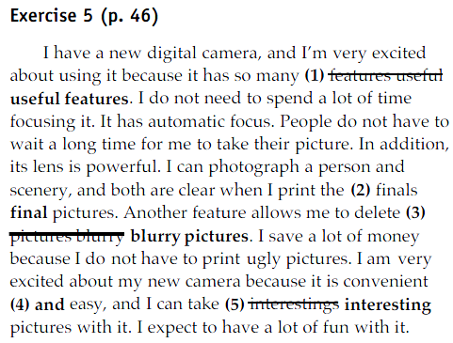

PART 5: PUTTING IT ALL TOGETHER
a. Exercises 1-4/ p.47-48
Answer keys
Exercise 1 (p. 47) Answers will vary.
1. I am reading Pride and Prejudice.
2. In the photograph, the person is holding a newborn baby.
3. Laura went to Italy and Spain for a while.
4. It is a picture of Mount Rushmore.
5. The water flows through the Amazon Rain Forest.
6. Our room looked out over the Pacific Ocean.
Exercise 2 (p. 47)
1. We planted a vegetable garden behind the house.
2. Friendly people are usually happy.
3. She has a different idea.
4. My favorite books are historical novels.
5. The class is upset about the math test.
Exercise 3 (p. 48)
Answers will vary.
1. My twin brother owned a silver sports car.
2. My best friend has a married older sister.
3. The dead man was a history teacher.
4. This tiny object is actually a powerful and expensive computer.
5. I have a cactus plant and a beautiful Siamese cat.
6. There is a pine tree next to the red brick house.
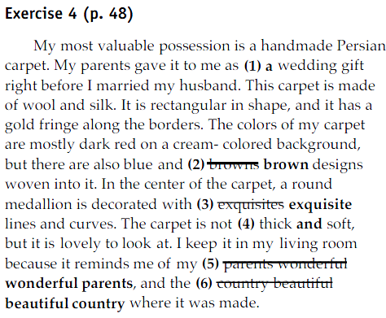
b. Write a short paragraph (70-80 words) about a chosen topic
c. Self-correction and Peer-correction

UNIT 3 EXAMPLE PARAGRAPHS

PART 1: STIMULATING IDEAS
a. Analyze:
Reading Text: “Like a mule”.
Exercise 4/ p.57
Answer keys:
A. 1. She does not take advice. She does not change her mind easily. She defends her opinions.
2. Other people might get upset because she says what she thinks.
B. 1. I am a stubborn person.
2. The supporting details will give examples of ways that she is stubborn.
3. She gives three main examples: she did not take advice about a job; she did not change her mind
about the color car she wanted; and she told her opinion of a woman she did not like.
4. She insisted on buying a white car even though it was inconvenient and she had to drive very far to get it.
5. Yes.
6. My life is not always easy but I am proud to be a strong and stubborn woman. Yes.
7. She tells her feelings about being stubborn.
8. The author likes being stubborn. She feels that it is a sign of strength. No one can make her change.
b. Lesson: EXAMPLE PARAGRAPH
- Definition: An example paragraph gives examples so that readers clearly understand the writer’s ideas about the topic
- Descriptive organization:
- Topic sentence:
- The topic
- Controlling idea: what the writer will say about the topic
- Supporting sentences:
- Examples
- Concluding sentence:
- Restate the topic sentence

PART 2: BRAINSTORMING AND OUTLINING
2.1. Brainstorming skill
a. Lesson: review the skill
b. Practice
Exercise 1, 2/ p.55
Answer keys: The answer will vary
2.2. Outlining skill
a. Lesson: review the skill
b. Practice
Exercise 5/ p.58
Answer keys: The answer will vary

PART 3: DEVELOPING YOUR IDEAS
a. Lesson
- Using Examples as Supporting Details
- Be specific
- Clearly relate to the controlling idea
- Not simply repeat the topic sentence
b. Practice
Exercise 3/ p. 61
Answer keys:
2. a, c - 3. b, c - 4. a, c - 5. b, c
Exercise 4/ p. 62
Answer keys: Answers will vary.
2. For example, he always greets patients in a friendly way.
3. For example, I have trouble sleeping at night because they are playing lo ud music.
4. For example, she tells funny stories about her family.
5. For example, he runs away when his mother calls him.
6. For example, she can sing and play the guitar.

PART 4: EDITING YOUR WRITING
4.1. Forming and Using the Simple Present
a. Lesson:
The simple present tense is used:
- To express habits, general truths, repeated actions or unchanging situations, emotions and wishes
- To give instructions or directions
- To express fixed arrangements, present or future
- To express future time, after some conjunctions: after, when, before, as soon as, until
Forming the simple present tense:
Affirmative Interrogative Negative
I think Do I think? I do not think
You think Do you think? You do not think
He thinks Does he think? He does not think
She thinks Does she think? She does not think
It thinks Does it think? It does not think
We think Do we think? We do not think.
They think Do they think? They do not think.
Notes on the simple present, third person singular
- In the third person singular the verb always ends in -s:
- Negative and question forms use DOES (= the third person of the auxiliary 'DO') + the infinitive of the verb.
- Verbs ending in -y : the third person changes the -y to –ies (Exception: if there is a vowel before the –y)
- Add -es to verbs ending in:-ss, -x, -sh, -ch:

4.2. Subject – Verb Agreement
a. Lesson
Basic Rule. A singular subject (she, Bill, car) takes a singular verb (is, goes, shines), whereas a plural subject takes a plural verb.
Rule 1. A subject will come before a phrase beginning with of. This is a key rule for understanding subjects. The word of is the culprit in many, perhaps most, subject-verb mistakes.
Rule 2. Two singular subjects connected by or, either/or, or neither/nor require a singular verb.
Rule 3. The verb in an or, either/or, or neither/nor sentence agrees with the noun or pronoun closest to it.
Rule 4. As a general rule, use a plural verb with two or more subjects when they are connected by and.
Rule 5a. Sometimes the subject is separated from the verb by such words as along with, as well as, besides, not, etc. These words and phrases are not part of the subject. Ignore them and use a singular verb when the subject is singular.
Rule 5b. Parentheses are not part of the subject.
Rule 6. In sentences beginning with here or there, the true subject follows the verb.
b. Practice
Exercise 3/ p. 67
Answer keys
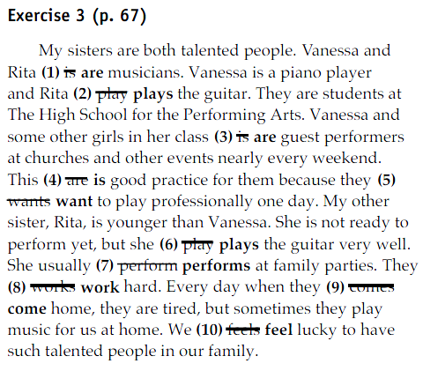

PART 5: PUTTING IT ALL TOGETHER
a. Exercises 1-5/ p. 69-71
Answer keys
Exercise 1 (p. 69)
1. a, b, d - 2. b, c, d - 3. a, b, d - 4. a, c - 5. b, c
Exercise 2 (p. 70)
Answers will vary.
1. They worry about their grades. Many of them are living away from home for the first time.
2. An organized person can find things easily. An organized person gets more work done.
3. I had a lot of friends. I lived at home with my parents, and I did not have to work.
4. My first computer broke, so I bought a new laptop. The laptop never worked properly, and
finally I had to return it to the store where I bought it.
5. You can go scuba diving. You can go surfing in the waves.
Exercise 3 (p. 70)
Answers will vary.
1. Writing a good paragraph takes time and patience.
2. Careful drivers look before turning.
3. A tourist takes a lot of photographs.
4. My hometown has many temples and shrines.
5. A hero saves people.
6. My cell phone takes pictures.
Exercise 4 (p. 71)
1. drive 2. Performs 3. does not agree 4. Watches 5. Share 6. Studies
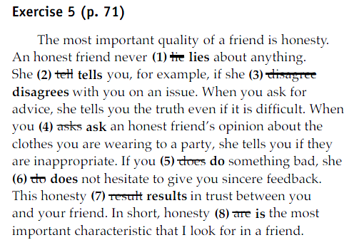
b. Write a short paragraph (70-80 words) about a chosen topic
c. Self-correction and Peer-correction

UNIT 4 PROCESS PARAGRAPHS

PART 1: STIMULATING IDEAS
a. Analyze:
Reading Text: “Royalty in your garden”.
Exercise 4/ p.82
Answer keys:
A. 1. They think that roses will be difficult to grow.
2. Roses need rose food, plenty of sunshine, and water.
3. Rose plants lose their leaves and flowers in winter, and they might look dead.
4. Answers will vary.
B. 1. Roses are royalty among flowers.; b
2. a, b, c, d
3. If you continue to take care of your roses in this simple way, they will produce beautiful flowers
year after year. b
b. Lesson: PROCESS PARAGRAPH
- Definition: An process paragraph describes the steps necessary to perform a task or process.
- Process organization:
- Topic sentence:
- The process the writer will describe
- Supporting sentences:
- A sequence of step
- Additional information: background information (why the step is necessary), tools, etc
- Concluding sentence:
- Restate the topic sentence

PART 2: BRAINSTORMING AND OUTLINING
2.1. Brainstorming skill
a. Lesson: review the skill
b. Practice
Exercise 1, 2/ p.79, 80
Answer keys: The answer will vary
2.2. Outlining skill
a. Lesson: review the skill
b. Practice
Exercise 5/ p.83
Answer keys: The answer will vary

PART 3: DEVELOPING YOUR IDEAS
a. Lesson: Using Time Order Words in Process Paragraphs
- First (of all),
- Secondly, Next, After that, Then…
- Finally
b. Practice:
Exercise 3, 4/ p. 86, 87
Answer keys
a. 2 - b. 5 - c. 3 - d. 8 - e. 7 - f. 6 - g. 4 - h. 1
Exercise 3, 4/ p. 86, 87
Answer keys
1. First, 2. Before 3. After 4. Later, 5. Finally,

PART 4: EDITING YOUR WRITING
4.1. Using Imperatives
a. Lesson
- The verb in an imperative addresses the reader or listener directly
- The imperative uses the base form of the verb
- An imperative sentence does not require a subject, but the subject you is always implied
b. Practice
Exercise 1/ p. 90
Answer keys: 3, 4, 6
Exercise 2/ p. 91
Answer keys:
2. Fill water bottles and put them in the freezer the night before.
3. Dress in comfortable clothing and sneakers or sandals.
4. Debug your hard drive periodically.
5. Replace the water in the tank every week or two.

4.2. Modals of Advice, Necessity, and Prohibition
a. Lesson
Basic rules
Modal verbs never add an -s in the third person singular:
Modal verbs are followed by infinitive without to except from ought to.
Modal verbs don´t need auxiliaries to make negative sentences or questions:
Modal verbs only have one form. You need other verbs to express the same thing in the past, future
Expressing advice
We use should and ought to to express advice or make recommendations:
You should eat less fat if you want to lose weight.
You ought to relax if you don´t want to get ill.
Expressing necessity
We use need to to express necessity:
We need to buy some bread for lunch.
Expressing prohibition
We use mustn´t and can’t to express prohibition.
Children under 16 mustn´t go in there
b. Practice
Exercise 3/ p. 92
Answer keys: Answers will vary.
2. must This is required by law.
3. must This is a law.
4. should This a suggestion or a recommendation, but is not required.
5. must This is a strong prohibition.
Exercise 4/ p. 93
Answer keys: Answers will vary.
2. You must use a bulb with the correct wattage. You should not change the bulb before turning off the light.
3. You must fill out an application. You should not arrive late to the job interview.
4. You must not cheat. You should eat a healthy breakfast on the day of the test.
5. You should not drive fast. You must turn on your windshield wipers and your headlights.

PART 5: PUTTING IT ALL TOGETHER
a. Exercises 1-3/ p. 95, 96
Answer keys
Exercise 1 (p. 95)
1. First, 2. Second, 3. Next, OR Then 4. Then OR Next, 5. Finally,
Exercise 2 (p. 96)
1. Buy a good fishing rod.
2. Warn the patient before you give him an injection.
3. Speak English with your classmates.
4. Type in your log-in ID and password.
5. Jog slowly at first.
Exercise 3 (p. 96)
Answers will vary.
1. must This is a rule of good etiquette.
2. must This is an important warning.
3. should This is a recommendation, but it is not a strict prohibition.
4. should This is a piece of advice.
5. must This is a law.
b. Write a short paragraph (70-80 words) about a chosen topic
c. Self-correction and Peer-correction

Vvvvvvvvvvvvvvvvvvvvvvvvvvvvvvvvvvvvvvvvvvvvvvvvvvvvvvvvvvvvvvv
UNIT 1 OPINION PARAGRAPHS

PART 1 STIMULATING IDEAS
a. Analyze
Reading Text: “A Vietnam paradise”.
Exercise 3/ p.105
Answer keys: Answers will vary.
Da Lat is a paradise because it has beautiful scenery, a pleasant climate, and many exciting activities.
b. Lesson: OPINION PARAGRAPH
- Definition: An opinion paragraph presents an opinion and tries to persuade readers that the opinion is a good one. The writer tries to make the readers agree with him or her.
- Descriptive organization:
- Topic sentence:
- Writer’s opinions about the topic
- Supporting sentences:
- Reasons
- Facts
- Examples
- Explanations
- Personal experience
- Concluding sentence:
- Restate the topic sentence
Comment on the opinion/ summarize the reasons

PART 2 BRAINSTORMING AND OUTLINING
2.1. Brainstorming skill
a. Lesson: review the lesson
b. Practice
Exercise 1, 2/ p.104
Answer keys: The answer will vary

2.2. Outlining skill
a. Lesson: review the lesson
b. Practice
Exercise 5/107
Answer keys: The answer will vary

PART 3 DEVELOPING YOUR IDEAS
3.1. Using Reasons to Support an Opinion
a. Lesson
- A fact is a piece of information that people generally agree is true. In an opinion paragraph, a writer might use scientific, historical, or other types of facts.
- An explanation cannot be proven (like a fact can) but it still helps the reader understand why the writer holds a certain opinion.
- An experience is something that happened to you or someone else. Writers often use experiences to show how they were influenced to think a certain way.
b. Practice
Exercise 3/ p. 109
Answer keys
1. a. Fact b. Explanation c. Experience d. Fact
2. a. Explanation b. Fact c. Experience d. Fact
3. a. Explanation b. Fact c. Experience d. Fact
Exercise 4/ p.110
Answer keys: Answers will vary.
2. Brazil
When I was there, I made many new friends, and everyone was so hospitable.
3. Rome
The architecture is stunning.
4. Charlottesville, Virginia
The cost of living is very low.
3.2. Writing practice: first draft
Exercise 5/ p. 111

PART 4 EDITING YOUR WRITING
4.1. Using There is/ There are to Introduce Facts
a. Lesson
We often use there + to be … as a subject but they do not refer to any object. There is / are is used to introduce a topic, or say that something exists.
b. Practice
Exercise 1 / p. 113
Answer keys
2. is - 3. are - 4. are - 5. is - 6. is
Exercise 2 / p.114
Answer keys
2. There are no houses on the island.
3. There are colorful birds in the jungle.
4. There are many international restaurants downtown.
5. There are many vendors on the beach.
6. There is a lot of good seafood along the coast

4.2. Using Because of and Because to Give Reasons
a. Lesson
Because of and because are both used to introduce reasons.
Because of is a preposition, it is generally followed by a verb+ing or a noun.
Because is a conjunction, it is followed by a subject and a verb.
b. Practice
Exercise 3/ p. 114
Answer keys
2. because 3. because of 4. Because 5. Because 6. because of
Exercise 4/ p. 114
Answer keys: Answers will vary.
2. My city is beautiful because of the many trees and the clear blue skies.
3. My city is interesting because it has people from all over the world.
4. I would like to live in a small town because it is safer than the big city.
5. I do not want to live in a big city because of the pollution.
6. The best city to live in is Vancouver because of the wonderful people.
Exercise 5/ p. 115
Answer keys
I was very sad when I had to leave Rio de Janeiro because it is the best place on earth. Rio is important to me (1) because of because my family still lives there. However, I think anyone who moves there will agree it is a wonderful place. That is because Rio has something for every personality. First (2) there is there are the people. Rio is famous (3) because of because many beautiful people live there, especially in the beach neighborhoods, such as Ipanema. The city is very fun during the Carnaval when Brazilians dress up in costumes and dance in the streets and nightclubs. Rio is also beautiful (4) because because of its location. The city is on the Atlantic Ocean. (5) There is There are a lot of beaches, and they are full of activity every day. The scenery is spectacular as well. You can see great geological formations, such as the granite mountain
called Sugar Loaf, and on another peak named Corcovado, you can see an enormous statue that looks over the city. Brazil also has many varieties of music (6) because because of the many cultures and traditions. Finally, (7) there are there is also a place for people who enjoy tranquility. The botanical gardens are filled with exotic varieties of plants and animals. So Rio de Janeiro
is a place with many different faces. It can be beautiful, crazy, and peaceful depending on your mood.

PART 5 PUTTING IT ALL TOGETHER
a. Exercises 1-3/ p.117-119
Answer keys
Exercise 1 (p. 117)
1. a. Explanation b. Fact c. Experience d. Explanation
2. a. Fact b. Explanation c. Explanation d. Experience
3. a. Experience b. Fact c. Fact d. Explanation
Exercise 2 (p. 118)
1. There are whales in Puget Sound in the summer.
2. There is gold in Siberia.
3. There are no penguins in Florida.
4. There is no cure for cancer.
5. There are many stories about the first blue-eyed tribes that lived in Argentina.
6. There are beautiful terraced hillsides in China.
Exercise 3 (p. 118)
1. because of 2. Because 3. Because 4. Because 5. because of 6. because of
b. Writing practice: final draft
Test: Time writing
c. Self-correction and peer-correction

UNIT 2 NARRATIVE PARAGRAPHS

PART 1 STIMULATING IDEAS
a. Analyze
Reading Text: “The best hamburger of my life”.
Exercise 3/ p.127
Answer keys
The hamburger was memorable because the author ate it with Sergio Verdirame, the author’s favorite soccer player.
b. Lesson: NARRATIVE PARAGRAPH
- Definition: A narrative paragraph tells a story.
- Descriptive organization:
- Topic sentence:
- What the story will be about
- When and where the story took place
- Capture the reader’s interest
- Supporting sentences:
- Sequences of events
- Sensory details
- Writer’s feelings
- Concluding sentence:
- Wrap-up the story
Comment why the experience is important and how the writer feels

Part 2 Brainstorming and Outlining
2.1. Brainstorming skill
a. Lesson: review the skill
b. Practice
Exercise 1, 2/ p.125-126
Answer keys: The answers will vary
2.2. Outlining skill
a. Lesson: review the skill
b. Practice
Exercise 5/129
Answer keys: The answers will vary

PART 3 DEVELOPING YOUR IDEAS
3.1.Using Sensory and Emotional Details
a. Lesson
Sensory details give information about how something looks, smells, tastes, feels, or what it sounds like
Emotional details help the reader understand the writer’s feelings.
b. Practice
Exercise 3/ p. 132
Answer keys
2. E 3. E 4. S 5. S 6. S
Exercise 4 / p. 132
Answer keys: Answers will vary.
2. The fish was spicy and slightly sweet, and it melted in my mouth.
3. We could see purples, reds, yellows, whites, and pinks, and the smell of jasmine mixed with
Gardenia was heavenly.
4. There was trash everywhere, and it smelled like a garbage can.
5. I remember the feel of cool water flowing over my body.
6. It smelled of coffee and spices, and there was always the sound of conversation.
Exercise 5 / p. 132-133
Answer keys: Answers will vary.
2. She always wrote funny stories that made me laugh, and I realized that she was a cheerful
person no matter what happened to her.
3. Now, I always feel glad when I see him at the end of the day.
4. I experienced many emotions mixed together including fear and excitement.
5. I was terrified and wanted to run away.
6. I was filled with pride and a sense of relief.

3.2. Showing Order of Events in Narrative Paragraphs - Showing Simultaneous Events
a. Lesson
when, lately, at the same time, once, immediately, already, final, during, now, little by little, after a while
b. Practice
Exercise 6/ p. 134
Answer keys
a. 1 b. 7 c. 3 d. 2 e. 8 f. 5
3.3. Writing practice: writing a first draft
Exercise 7/ p. 135

PART 4 EDITING YOUR WRITING
4.1. Forming and Using the Simple Past
a. Lesson
You always use the simple past when you say when something happened, so it is associated with certain past time expressions
- frequency: often, sometimes, always
- a definite point in time: last week, when I was a child, yesterday, six weeks ago
- an indefinite point in time: the other day, ages ago, a long time ago
b. Practice
Exercise 1/ p. 137
Answer keys
2. talked 3. Carried 4. called, arrived 5. Served 6. Were 7. met, was 8. climbed, visited
Exercise 2 / p. 138
Answer keys
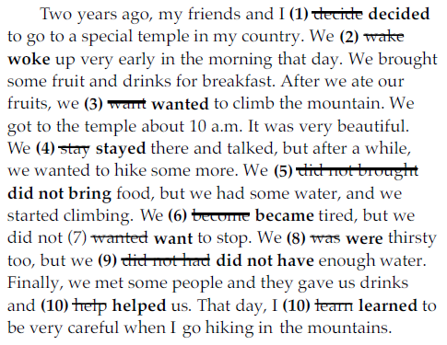
4.2. Forming and Using the Past Continuous
a. Lesson
- To describe the background in a story written in the past tense
e.g. "The sun was shining and the birds were singing as the elephant came out of the jungle. The other animals were relaxing in the shade of the trees, but the elephant moved very quickly.
- to describe an unfinished action that was interrupted by another event or action
e.g. "I was having a beautiful dream when the alarm clock rang."
- to express a change of mind
e.g. "I was going to spend the day at the beach but I've decided to get my homework done instead."
b. Practice
Exercise 3/ p. 139
Answer keys: Answers will vary.
2. I was eating dinner.
3. I was riding to work on the train.
4. I was working at a bookstore.
5. I was thinking about what I want to do this
Exercise 4/ p. 139
Answer keys:
2. I lived in Paris when I had a terrible car accident. I was living in Paris when I had a terrible car accident.
3. I worked on my paper and watched the game when he called. I was working on my paper and watching the game when he called.
4. A stranger stood in the doorway when we arrived home. A stranger was standing in the doorway when we arrived home.
5. We drove to the hospital when my wife told the taxi driver to stop the car. We were driving to the hospital when my wife told the taxi driver to stop the car.
6. In those days I worked and went to school, so I didn’t have much free time. In those days I was working and going to school, so I didn’t have much free time.
Exercise 5/ p. 140
Answer keys:
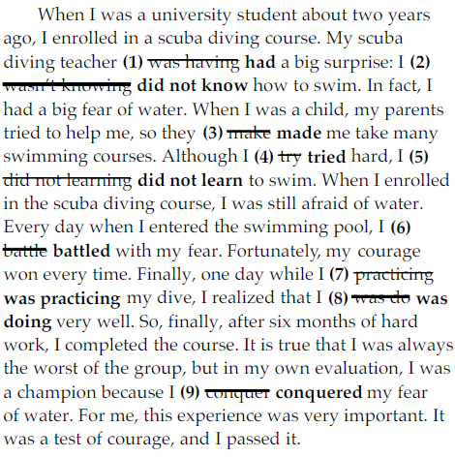

PART 5 PUTTING IT ALL TOGETHER
a. Exercises 1, 2, 3/ 142, 143
Exercise 1 (p. 142)
1. S 2. E 3. S 4. E 5. S 6. E
Exercise 2 (p. 142)
a. 1 b. 4 c. 7 d. 3 e. 2 f. 6 g. 8 h. 5 i. 9
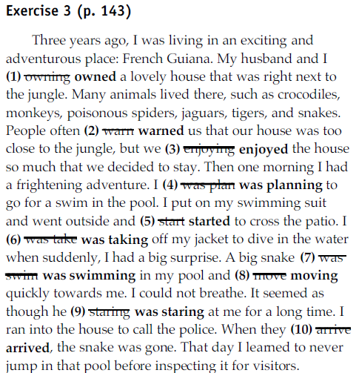
b. Writing practice: final draft
Test: Time writing
c. Self-correction and peer-correction
UNIT 3 PARAGRAPH TO SHORT ESSAY

PART 1 THE PARAGRAPH

  - Review of Paragraph Structure
- Topic sentence: topic + controlling idea
- Supporting ideas: support the topic sentence
- Concluding sentence: repeat the topic sentence in a different way

  - Formatting a Paragraph
Exercise 1/ P.3
Answer keys
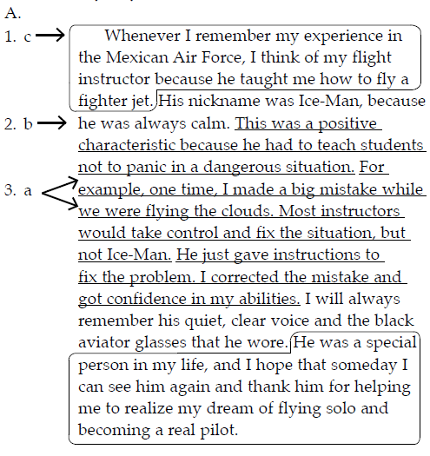
B. 1.The topic sentence is the first sentence circled above. Yes, the topic sentence does help you understand what the paragraph is about.
2. The supporting sentences are underlined above.There are five.
3. Yes, all the supporting sentences relate to topic sentence.
4. The concluding sentence is the last sentenced circled above. Yes, the concluding paragraph makes the paragraph feel finished.
Exercise 2/ P.3
Answer keys: Answers will vary.
The boy takes a risk trying to climb a coconut tree when he was young, which is dangerous.
Exercise 3/ p. 4
A. 1. The topic sentence is the first sentence, “When I was a boy and first learning about the world, I took a big risk.”
2. Yes, the first sentence is indented.
3. There are 13 supporting sentences. They are after the first sentence and before the last.
4. And the worst part was that every day I had to walk past the coconut tree and remember my
foolish risk.
B. Answers will vary.
1. The writer was in the yard of his family’s house.
2. He was with his friends.
3. He fell from the coconut tree and broke his arm and one of his ribs.
4. Answers will vary.

1.3. The Topic Sentence
Exercise 4, 5, 6, 7, 8/ P. 5-8
Answer keys
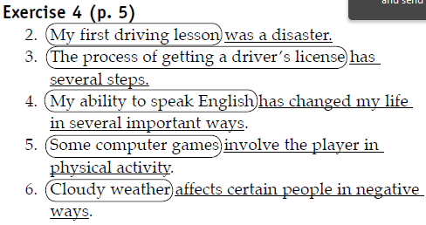
Exercise 5 (p. 6) 2.b 3.c 4.c 5.a 6.b
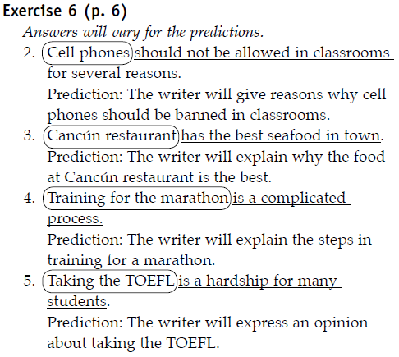
Exercise 7 (p. 7) 2.b 3.a 4.b
Exercise 8 (p. 7)
Answers will vary.
A. 2. Revised topic sentence: Students eat a lot of fast food for several reasons.
3. Revised topic sentence: When I want to be alone to think, I visit a beach near my house.
4. Revised topic sentence: Teenagers spend too much time shopping.
5. Revised topic sentence: Hurricanes cause much damage to property in Florida every year.
B. 2. Topic: Students eat a lot of fast food
Controlling idea: for several reasons
This paragraph will be about: reasons (or causes) of why people eat a lot of fast food
3. Topic: A beach near my house
Controlling idea: I visit the beach when I want to be alone
This paragraph will be about: a description of the beach
4. Topic: Many teenagers
Controlling idea: spend too much time shopping
This paragraph will be about: an opinion of why too much shopping is bad for teenagers
5. Topic: Hurricanes
Controlling idea: hit Florida every year
This paragraph will be about: the effects of hurricanes in Florida

PART 2 UNITY AND COHERENCE
  - . Unity within a Paragraph
a. Lesson
- All sentences support a single idea
b. Practice
Exercise 1, 2, 3, 4, 5/ p.5-12
Answer keys
Exercise 1 (p. 9)
Answers will vary.
The writer’s grandfather’s talent is astronomy. Her mother’s older brother’s talent is story-telling. Her grandmother’s talent is painting.
Exercise 2 (p. 10)
1. My mother grew up in a creative and interesting family in Nepal. It is the first sentence.
2. Answers will vary. Example: The writer’s mother had a fascinating family with many artistic talents.
3. The sentence, “After my mother left Nepal, she studied computer programming in Wisconsin,” is
irrelevant.
4. Answers will vary. Example: This sentence is not about the writer’s mother’s childhood; nor is
it about her family. Consequently, it does not support the topic sentence.
Exercise 3 (p. 10)
2.a, b 3.b, c 4.b, c 5.a, c 6.a, b 7.b, c
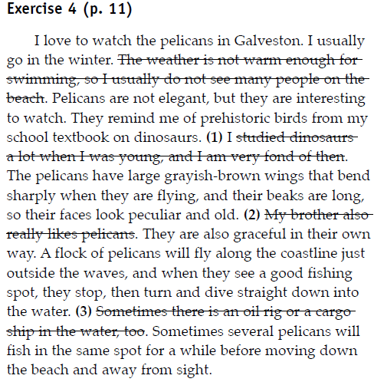
Exercise 5 (p. 12)
Answers will vary.
1.Team members can have fun. Team members can enjoy meeting new people.
2. I met interesting, new people. My teacher taught differently from teachers at my old school.
3. Travelers can explore small towns and scenic areas. The roads are well maintained and there
are many hotels, campgrounds, and restaurants available.
4. First, you need to think about what you will need when you arrive at your destination. Second, you should pack so that when you need a particular item you can access it easily.

2.2. Coherence within a Paragraph
a. Lesson
- Supporting ideas are organized in a logical way.
- Order: time, space, importance …
b. Practice
Exercise 6/ p.13
Answer keys: The writer gives four rules.
Exercise 7/ p.13
Answer keys
1. For people who like to act in the theater, there are several important rules to remember.
2. An actor should remain calm, and make up something to say until remembering the next line.
3. The ideas move from less important to more important ideas.
Exercise 8/ p.14
Answer keys: a.10 b.1 c.2 d.4 e.8 f.3 g.6 h.5 i.7 j.9

PART 3 FROM PARAGRAPH TO SHORT ESSAY
  - The Paragraph and the Short Essay
a. Lesson: ESSAY ORGANIZATION
- Introduction:
Hook: capture reader’s attention
Background information
Thesis statement: topic + controlling idea
- Body paragraph(s):
Topic sentence – supporting ideas – concluding sentence: support the thesis statement sentence
- Conclusion: restate main idea/ summarize
b. Practice
Exercise 1/ p. 16
Answer keys
The short essay is more interesting because it has more
details. The more the reader learns about Uncle Patricio,
the more real he becomes in the reader’s mind.
Exercise 2/ p. 17
Answer keys: Answers will vary.
1. In the short essay introduction there are details about the members of the writer’s family. The
paragraph only mentions Patricio.
2. Patricio looks like an interesting, old man now.
3. There are details about his physical appearance.
4. Patricio has an interesting life story.
5. There are details about the places he visited.
6. The concluding paragraph tells more about the writer’s feelings about Patricio, why he is
interesting, and hoping to learn about the tattoo.
Exercise 3/ p.18
Answer keys
A. A restaurant job is a convenient choice for a college student for several reasons.
B. During my childhood in El Salvador, I learned an important lesson about being careful.
Writing practice: first draft

PART 4 EDITING YOUR WRITING
4.1. The Sentence
4.2. Simple and Compound Sentences
a. Lesson
Simple and compound sentences. A simple sentence contains one independent clause. A compound sentence contains more than one! Put another way: a simple sentence contains a subject and a predicate, but a compound sentence contains more than one subject and more than one predicate.
b. Practice
Exercise 1/ p.21
Answer keys
1.1 2.2 3.2 4.2 5.2 6.1

4.3. Run-on Sentences
a. Lesson
Run-on sentence. A grammatically faulty sentence in which two or more main or independent clauses are joined without a word to connect them or a punctuation mark to separate them
b. Practice
Exercise 2/ p.22
Answer keys
2. Almost everyone in her neighborhood speaks her language, so she does not have to use English.
3. Credit cards are convenient, but they are also dangerous.
4. I did not have experience, but I tried to get a job.
5. Every time I travel, either I take a suitcase or I take a backpack.
6. My lucky number is seven, and my favorite color is red.

4.4. Dependent Clauses
a. Lesson
A subordinate clause or dependent clause is a clause that provides a sentence element with additional information, but which cannot stand as a sentence.
b. Practice
Exercise 3, 4, 5/ p.22- 23
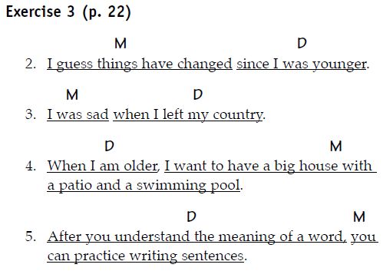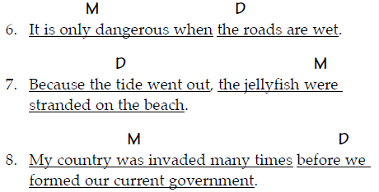

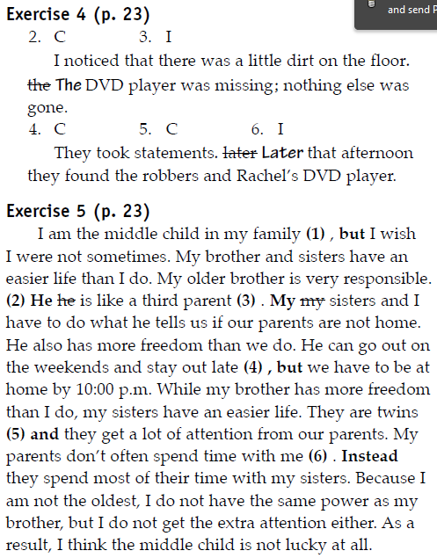

PART 5 PUTTING IT ALL TOGETHER
a. Exercises 1-5/ p.24 – 25
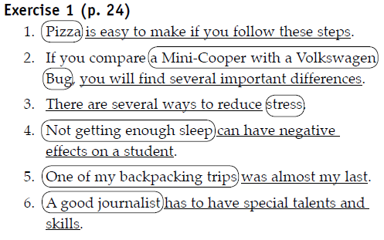
Exercise 2 (p. 24)
When I want to eat steak, I go to my favorite restaurant, Saltgrass Steakhouse, because I always
have a good experience. I love walking through the big heavy wooden doors because the spicy smell of grilled meat makes my mouth water. The hostess knows my family, and she always gives us a good seat where we can watch the other customers and enjoy the cowboy decorations on the walls. The service is friendly and efficient. (1) On the other hand, the cook is often grumpy. (2) He yells at the waiters sometimes. The waiters always bring crayons and paper for my daughters. I always order the rib-eye steak because the grilled meat is tender and seasoned with delicious spices. After dinner, we talk and enjoy the atmosphere. (3) It is not good to eat there every day because the beef
has a lot of fat. (4) All red meat has a lot of fat, and it can cause problems such as high cholesterol. (5) I like to eat at Saltgrass Steakhouse once a month, but I would eat there more often if I had the money. It has the best steak in the city.
Exercise 3 (p. 25)
b. Zombie tag is easy to play if you follow the steps below.
Exercise 4 (p. 25)
1. I
My father decided to go to dental school he . He was at the top of his class.
2. I
My writing has improved a great deal, but I still need to work on my grammar.
3. I
When I am an industrial engineer, I want to
design kitchen appliances.
4. C
5. I
I have never been afraid of snakes. I think they are beautiful.
6. C
Exercise 5 (p. 26)
The memory of summer vacations at my grandmother’s home in Ayutta, Thailand, always makes
me happy. I loved this house very much because it was a beautiful and spacious place (1) where all the members of my family could gather to spend time together and enjoy nature. The house was located on a quiet stretch of river under a clear blue sky. It was a traditional, waterfront, Thai-style home (2) . It it was built from teak wood. The tall, green trees around the house provided shade along the river bank. Inside the house, there were many rooms (3) , so my uncle’s and my aunt’s families could all come together at the same time. When we woke up, we could hear the sound of
singing birds (4) . We children always rushed outside to breathe fresh air, and dig our toes into the sand. In the afternoon, we played in the shade of the trees, swam in the river, and dug in the gardens. The adults watched us from the patio (5) . They they could see us and we could see them. This home was the center place of my family (6) . I like to think about it when I feel lonely.
b. Writing practice: Write a short essay (150-250 words) about a chosen topic

UNIT 4 DESCRIPTIVE ESSAYS

PART 1 STIMULATING IDEAS
- Analyze
Reading Text: “The best pizza in town and maybe the world”.
Exercise 4/ p.34
Answer keys
A. 1. c
2. the second paragraph
3. b
Answers will vary.
B. 1. I have eaten pizza in many places, and none is as good as the pizza of Cabimas.
2. sauce oozes, rich melted cheese, crunchy crust, thick tomato sauce, gooey cheese.
3. I enjoy it so much I won’t share it, I feel happy, I am in heaven.
4. I am convinced that the best pizza in the world is still at Papa’s restaurant a couple of blocks from the house where I grew up.
Exercise 5/ p.35
A 1. I have eaten pizza in many places, and none is as good as the pizza of Cabimas.
2. many varieties of pizza, eat two pizzas in one night, customers have to wait in line
3. The best pizza in the world is at Papa’s restaurant.nswer keys
b. Lesson
- Definition: A opinion paragraph presents an opinion and tries to persuade readers that the opinion is a good one. The writer tries to make the readers agree with him or her.
- Descriptive organization:
- Topic sentence:
- Writer’s opinions about the topic
- Supporting sentences:
- Reasons
- Facts
- Examples
- Explanations
- Personal experience
- Concluding sentence:
- Restate the topic sentence
- Comment on the opinion/ summarize the reasons

PART 2 BRAINSTORMING AND OUTLINING
2.1. Brainstorming skill
a. Lesson: review the skill
b. Practice
Exercise 1/ p.32
Answer keys: The answers will vary
Exercise 2/ p.32
Answer keys
A. 1. spicy, salty
2. smooth, thick
3. pungent, familiar
4. colorful, beautiful
2.2. Outlining skill
a. Lesson: review the skill
b. Practice
Exercise 6/ p.36
Answer keys: The answers will vary

PART 3 DEVELOPING YOUR IDEAS
3.1.Prepositional phrases
a. Lesson
A prepositional phrase will begin with a preposition and end with a noun, pronoun, gerund, or clause, the "object" of the preposition.
b. Practice
Exercise 3/ p. 39
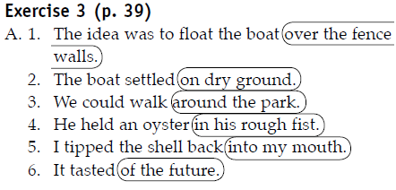
B. My father told me that we should always respect nature and learn where our food comes from. He said that food tasted better when you got it yourself and ate it in a natural place. To show me this was true, he took me to the ocean, where we caught our own delicious crabs and ate them.
I will always remember the taste of the crabs we caught that day. The beach was quiet and still at six
o’clock. The tide had just come in, so there were many crabs walking slowly on the white sand. We sat a few feet away from my father’s special crab traps. The traps were made of bamboo, and they looked like round cages, but one side had a small entrance for the crab to go in. There were some small, fragrant fish in the trap. The fishy smell made the crabs hungry, so they crawled into the traps. We watched the crabs walk into the traps, and I smelled the strong smell of the dark, oily fish.
Overhead, we heard the sounds of seagulls and pelicans in the sky. I think the seagulls wanted to eat the fish, too. Once the traps were full, we took off our shoes and threw them over our shoulders so we could walk on the wet sand and feel the water pushing and pulling at the beach. Later, we built a fire and ate boiled crabs on the beach. We cracked their shells. The meat was white and pinkish and tender. It tasted sweet and a little salty. We did not want to stop eating them. We sat on the sand surrounded by crab shells and watched the sun go down into the ocean. From that day on, I knew my father was right. Food tastes best when it is something that you have caught or grown yourself. I have eaten crab many times since then, but it has never tasted as good as it did that day.

3.2.Adding details to sentences
a. Lesson
b. Practice
Exercise 4/ p. 40
Answer keys
2. We quickly returned from the gourmet grocery store.
3. I entered the large, spacious apartment.
4. My friend slowly cleaned the freshly picked spinach.
5. We put the spinach in a large, iron frying pan.
6. Our guests enjoyed the sophisticated dinner.

3.3.Similes
a. Lesson
A simile cn use preposition like + noun/ noun phrase
A simile can also use as … as + noun or noun phrase
b. Practice
Exercise 5/ p. 41
Answer keys 1.f 2.c 3.e 4.b 5.d 6.a
Exercise 6/ p. 41
Answer keys: Answers will vary.
1. My best friend drinks coffee like water.
2. My place where I grew up looks like paradise.
3. My home is like a sanctuary.
4. Listening to my favorite music is like relaxing on a beach.
5. Coffee is as delicious as chocolate.
6. TV is like food.
3.4.Writing practice: first draft
Exercise 7/ p. 41

PART 4 EDITING YOUR WRITING
4.1.Using Adjectives
a. Lesson
Adjectives describing nouns: There is a venomous snake on your shoulder.
Adjectives describing pronouns: There’s something strange on your shoulder.
Attaching adjectives to linking verbs: George’s latest jazz composition sounds awful.
b. Practice
Exercise 1/ p. 43
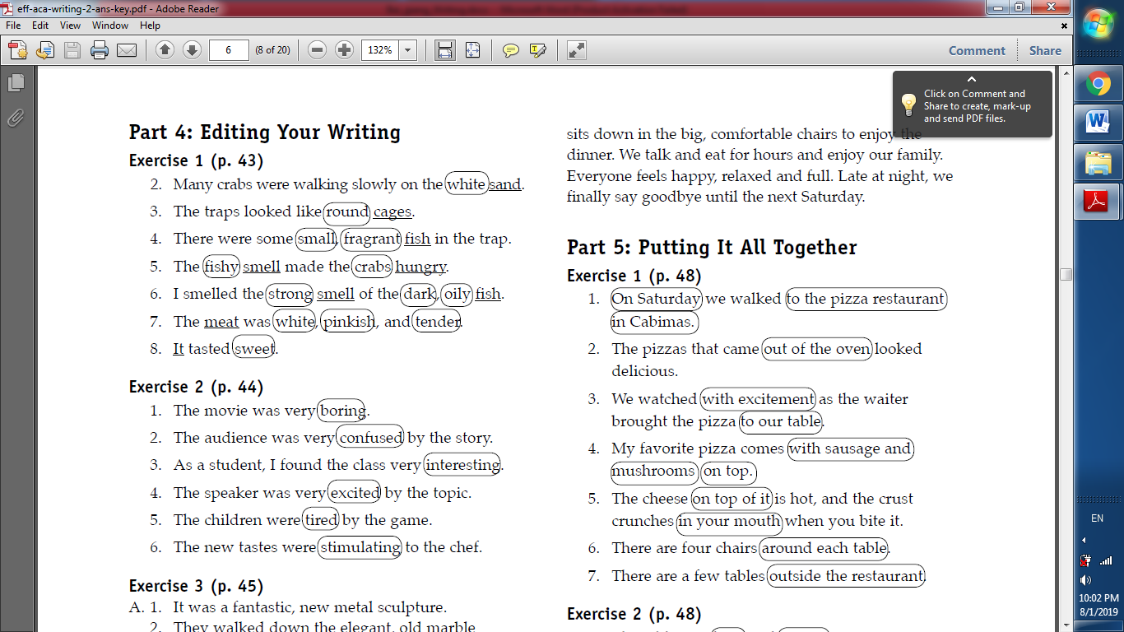
4.2.Formation of adjectives
a. Lesson
b. Practice
Exercise 2/ p. 44
4.3.Order of adjectives
a. Lesson
General opinion Specific opinion Size Shape Age Colour Nationality Material
b. Practice
Exercise 3, 4/ p. 45, 46
A. 1. It was a fantastic, new metal sculpture.
2. They walked down the elegant, old marble staircase.
3. The museum had beautiful, wooden entrance doors.
4. There were huge, bright blue lights to mark the entrance.
5. The food was served in simple, tiny portions on small, modern dinner plates.
6. The women wore stunning, new velvet dresses.
Answers will vary.
B. 1. It was a fast racing car.
2. They lived in a large Victorian house.
3. The house was located on a long, winding street.
4. She enjoyed the interesting foreign movie.
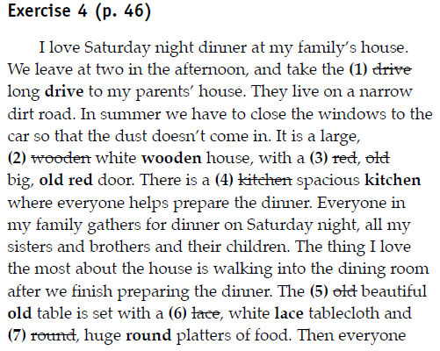

PART 5 PUTTING IT ALL TOGETHER
a. Exercises 1-4/ p. 48, 49
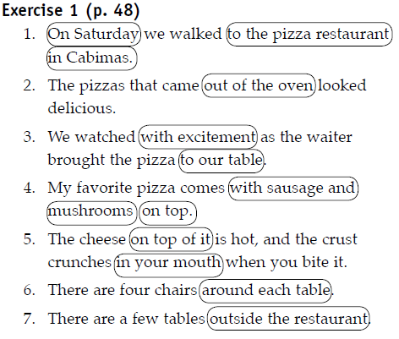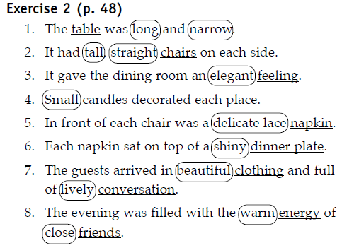
Exercise 3 (p. 49)
1. The exciting, enormous wild jungle was filled with life.
2. The huge, ancient stone temples could be seen for miles.
3. The tall, rough gray steps led to the top.
4. A spectacular, vast green view could be seen in every direction.
5. People marveled at the amazing, ageless tropical landscape.
6. In their amazement, they forgot their small, shiny modern cameras.
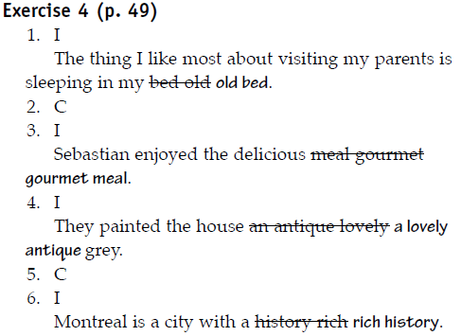
b. Writing practice: final draft
Time writing/ p.49s

